**Gilgit:**

Rakaposhi

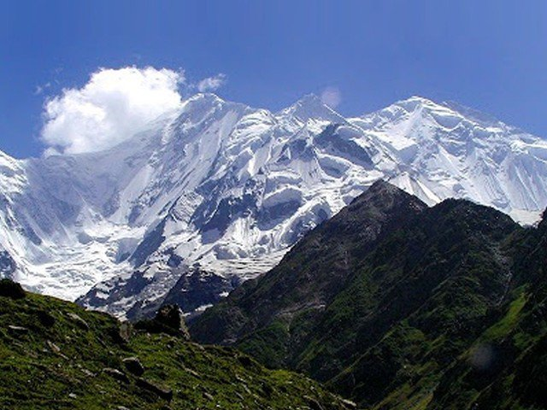

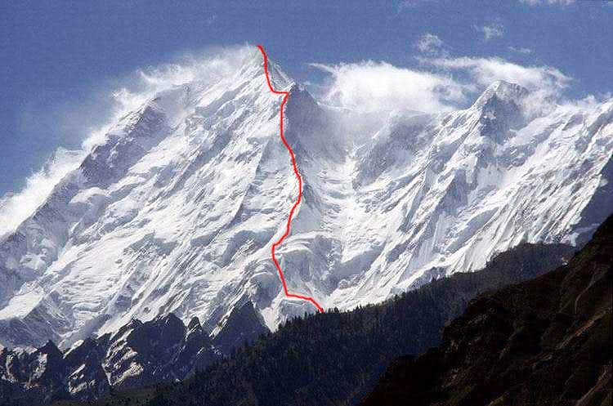

**Rakaposhi** is a mountain in the Karakoram mountain range in the Gilgit-Baltistan region of Pakistan It is situated in the middle of Nagar Valley Nagar District and Danyore and Bagrote valley approximately 100km (62mi) north of the capital city Gilgit of the semi autonomous Gilgit-Baltistan region of Pakistan. Rakaposhi means "Snow Covered" in the local language. Rakaposhi is also known as Dumani ("Mother of Mist" or "Mother of Clouds"). It is ranked 27th highest in the world.